**QUESTION 1**

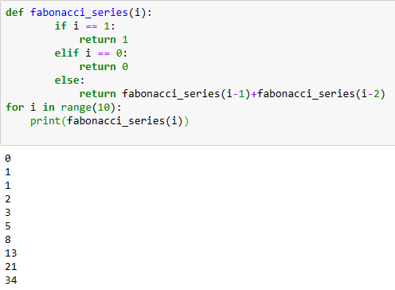

**QUESTION 02**

class Undo:

def __init__(self):

self.stack = []

def push(self,item):

self.stack.append(item)

def pop(self):

if self.stack:

print(self.stack.pop())

else:

print("Empty")

def is_empty(self):

if len(stack.state) == 0:

print("Stack is empty")

def display(self):

print(self.stack)

undo = Undo()

undo.push("X")

undo.push("Y")

undo.push("Z")

print("----------------DISPLAY-------------------")

undo.display()

print("-----------------POPPED-------------------")

undo.pop()

print("-----------------DISPLAY-------------------")

undo.display()

